# *Web Programming III (420-C30-HR)*

# *Assignment 1 – AJAX*

Date assigned: Wednesday, September 14, 2016

Date due: **Wednesday, September 28, 2016**

**Learning Objectives**

Upon successful completion of this assignment, the student will be able to:

* Use jQuery to read a text file
* Use the jQuery GET and POST methods to read and write XML files

To do:

**General idea of the assignment:**

Create a web application that allows the user to select a genre of music and display a list of the albums for that genre. The other part of the application allows the user to enter new album information and have it stored.

**Details:**

Your program must contain the following components:

**VIEW ALBUMS**

**An HTML page to View Albums**

This page is called viewAlbums.html and contains a form with a drop down list (or equivalent) which allows the user to select as genre of music and then displays all the albums for that genre.

The list of genres is retrieved from a file called genres.txt. Use a jQuery AJAX get command to read the files genres.txt. Once a genre is selected or changed, a server file getAlbums.php is called with the parameter ‘genre’ and the value one of the genres.

The possible genres are: Country, Folk, Jazz, Oldies, Pop, Rap and Rock.

When the get command returns, update a div with the information about each album in that genre (returned from the call to the getAlbums.php server code). Display the output formatted nicely and include: album title, artist, company, year published, condition and price. The format of the data returned is pictured below. NOTE: An album MAY have more than one artist; if that is the case, all artists must be displayed.

The possible values for condition are M – Mint, VG – Very Good, G – Good, P – Poor, VP – Very Poor. Display the expanded text and not the abbreviation.

Make sure you format things nicely using proper CSS techniques and varying colours/font sizes to make the display look good.

The div containing the information must update automatically every 10 seconds to include any other albums that might have been added.

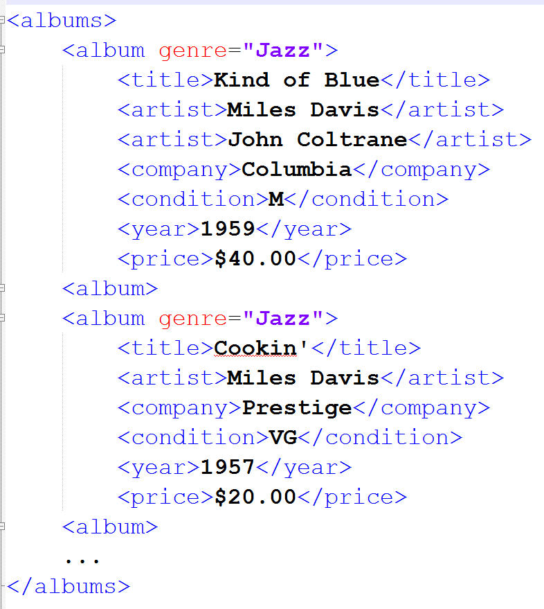

**ADD ALBUMS**

**A Second HTML page to Add Albums**

This page is called AddAlbums.html and has a form to allow the user to enter album information for a new album and save that information on the server. Storing the information is done using the PHP program addAlbum.php which is called using the POST method.

You must send the information to the program using a jQuery POST command and must use the name value pairs of all fields. The name in the name value pair (that is the name of the field from the form) corresponds to the element name of the entity. All entities are required and error checking must be done to make sure that the information sent is complete and accurate. Remember, use the power of the developer options in the browsers (especially FireFox and Chrome) to know what is being sent as parameters. YOU CANNOT USE A FORM WITH A POST METHOD. YOU **MUST** USE THE JQUERY METHOD POST TO SEND THE INFORMATION ASYNCHRONOUSLY.

**Other things**

1. There are marks for interface design. Use appropriate colours, labels, headers, etc. This does not mean make it garish or having flashing lights, it means make it professional. Design for mobile first.
2. Make the code efficient; there are marks for efficiency.
3. You must use HTML5 and (proper) CSS techniques for this assignment.
4. The application must be responsive at the bootstrap breakpoints which are: >=768px, >=992px and >=1200px. That is, the page must adjust at each of those breakpoints. You do NOT have to use bootstrap.

**To submit**

When you have completed the assignment zip the YourUserName_C30_A01 folder containing all the files for the assignment and copy it to the course page.